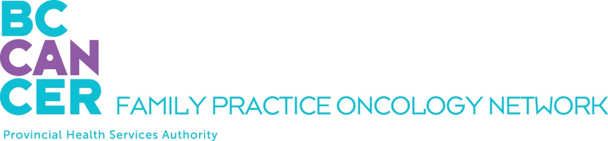

GPO Education Program Application
For Nurse Practitioners - 2 Week Program only:

Please ensure you have reviewed the Program mandate on the Network Website.

APPLICANT DETAILS

NAME OF APPLICANT:

First Name, Middle Initial, Last Name

ADDRESS
Street # and name, City, Province, Postal Code

TELEPHONE NUMBERS: EMAIL ADDRESS:
Home:
Office:
Mobile:

INTRODUCTORY MODULE YOU PLAN TO TAKE:

Spring 2022 Virtual Delivery: morning lectures, February 7 – 18, and afternoon lectures, February 28 – March 11

Fall 2022 Virtual Delivery: morning lectures, September 12 – 23, and afternoon lectures, October 3 – 17

REQUIRED ATTACHMENTS

PLEASE INCLUDE THE FOLLOWING WITH YOUR APPLICATION:

A letter of support from your program director

SUBMIT YOUR APPLICATION BY EMAIL

Please email this application as a PDF document to:

Dilraj Mahil, Project Coordinator
Family Practice Oncology Network
BC Cancer
600 W. 10th Ave.
Vancouver, BC V5Z 4E6
dilraj.mahil@bccancer.bc.ca

Kindly submit your application at your earliest convenience. We thank you for your interest and will advise you promptly as to your acceptance into the program.

