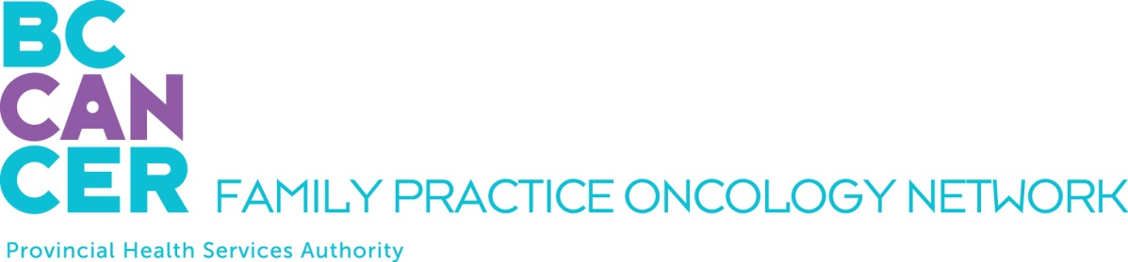

BC Cancer GPO Education Program Application

Please ensure you have reviewed the Program mandate on the Network Website.

APPLICANT DETAILS

NAME OF APPLICANT:

First Name, Middle Initial, Last Name

ADDRESS
Street # and name, City, Province, Postal Code

TELEPHONE NUMBERS:
Office:
Mobile:

EMAIL ADDRESS:

BC CANCER CENTRE/CLINIC WHERE YOU WILL BE EMPLOYED:

INTRODUCTORY MODULE YOU PLAN TO TAKE:

Spring 2022 Virtual Delivery: morning lectures, February 7 – 18, and afternoon lectures, February 28 – March 11

Fall 2022 Virtual Delivery: morning lectures, September 12 – 23, and afternoon lectures, October 3 – 17

Following the Introductory Module, 30 days of Clinical Rotation will be arranged at the Cancer Centre as part of your employment. A letter of completion from your BC Cancer Leader and a post program evaluation will be required in order to receive credit.

REQUIRED ATTACHMENTS AND REFERENCE

PLEASE INCLUDE THE FOLLOWING WITH YOUR APPLICATION:

A letter of support from your BC Cancer Leader (Professional Practice Leader or equivalent)

Current Curriculum Vitae

SUBMIT YOUR APPLICATION BY EMAIL

Ensure all documentation is available prior to submitting your application. Please email your complete application – including all attachments – as one PDF document (with this application form at the front) to:

Dilraj Mahil, Project Coordinator
Family Practice Oncology Network
BC Cancer
600 W. 10th Ave.
Vancouver, BC V5Z 4E6
dilraj.mahil@bccancer.bc.ca

Kindly submit your application at your earliest convenience. We thank you for your interest and will advise you promptly as to your acceptance into the program.

